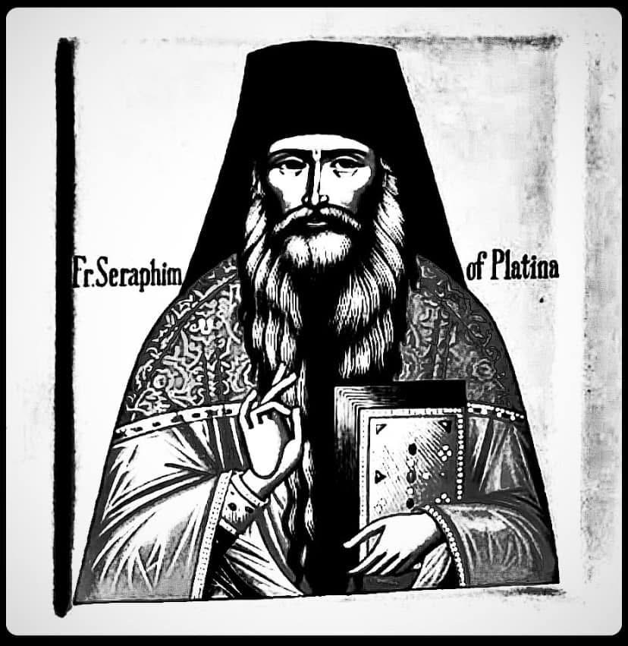

Father Seraphim (Rose).
The Mysteries of the Book of Revelation

Edited by Hegumen Herman (Podmoshensky)

Lecture delivered in English

Russian text by Vyacheslav Marchenko

Translation consultant Richard (in baptism - Thomas) Betts

Lecture (introduction to Father Seraphim's course on the Book of Revelation), delivered in Platina in 1980 at the summer sessions of the New Valaam Theological Academy.

This lecture serves as an introduction to the course that Father Seraphim included in the book co-authored by him and Archbishop Averky (Taushev) titled "The Apocalypse in the Teaching of Ancient Christianity." The introduction precedes the book and presents many arguments that are not included in it.

Contents:

1. Incorrect approach.
2. Revelation of mysteries.
3. Consolation for the suffering Church.
4. Dangerous to rely on one's opinion.
5. Correct approach.
6. Chronological error in the interpretations of the Book of Revelation.
7. Imminence of the coming of Christ.

1. Incorrect approach.

Our time - the twentieth century, and especially its latter part - more than any before it, fits the definition of apocalyptic, that is, a time when events occur that make the end of the world seem very near. The nature of the inventions of our time is such that even highly rational people talk about the possibility of destroying entire countries and even all of humanity with weapons such as nuclear bombs, or due to the production of modern monsters – environmental pollution, chemical and biological experiments, and so on.

Considering the characteristics of our time, it is not surprising that the Book of Revelation is now more popular than ever before. Therefore, at the beginning of this course, I would like to point out how we should approach this book. Today, both the interest in this book and most books about it are predominantly very superficial. One of the most popular books on this topic is "The Late Great Planet Earth" by Hal Lindsey, a Protestant evangelist. On the cover, it says: "An insightful look at incredible predictions concerning our generation." He talks about Israel, Russia, Gog and Magog, the end of the world, nuclear war. When you read all of this, your head starts spinning. It is written in a sensationalist tone: "Russia is Gog." "Gog, what have you planned?" and so on. When you read it superficially, it is very easy to get caught up in this book. But when you finish reading it, you are simply shaken by the excitement of everything happening. Phrases like, "Look at Iran," "Watch what Russia will do next." It is said that when ten nations in Europe unite, that is, when the tenth country joins the common market – that is a sign, those are the ten horns of the beast. The Northern king is obviously Russia; Egypt is the Southern king; China is the Eastern king, and so on, after a while, the reader's head starts spinning.

The excitement that reading such a book arouses is not fitting for a person studying Scripture. It is more at the level of cinema or television. The author writes in a tabloid style. Overall, his approach to this issue does not give an idea of what this book is about, the only result of reading it is the reader's excited state. Perhaps something he says is correct. Who knows? Maybe Russia really is the Northern king, but this is a secondary question. For the author, this is the main thing, but that is not the case. The main thing is something completely different.

We should not read the Book of Revelation for that reason. I know people who have read it, experiencing fear while reading – they read the entire book in one night, but when they finished reading, it did not become spiritual food for them. They are agitated, they are ready to run out into the street to grab newspapers to see what Russia is planning to do, who is ready to detonate whom. Spiritually, they have not progressed at all, as all they do is get lost in guesses and speculations, but the purpose of the book is not that.

2. Revelation of mysteries.

Therefore, we must approach this book, the culmination of biblical prophecies, in a completely different way. We must ask ourselves, "Why are we reading this book, the Book of Revelation?" We must first understand the purpose of writing this book. It can be said that this is a book of mysteries. In these mysteries, there is a profound meaning that is connected with the beginning and end of all that exists, with the ultimate goal of the world and humanity and the revelation of the eternal Kingdom of God. This word is often found in Scripture. In our services, we sing about a mystery that existed before the times and was unknown to the Angels, that is, the mystery of the Incarnation of the Lord. We do not call the usual phenomena in this world mysteries. Such phenomena as the Loch Ness Monster or the Bermuda Triangle are not mysteries. These are enigmas or strange, mysterious occurrences, but not mysteries in the sense in which they are spoken of in Scripture. On the other hand, "The mystery hidden in the depths of times" is the mystery of our salvation, of the redemption of our sins by Jesus Christ who came into this world. It is something in this world that already introduces us to another world, to the eternal Kingdom of God.

We also read in the Bible about the mystery of lawlessness; this is also something very deep, because in a certain sense it is the opposite of the mystery hidden in the depths of time – it is the mystery of what the devil does in the world. The devil also has an eternal kingdom: he wants to cast everyone into the abyss of hell. That is why the deeds done on earth by him are similar to those that start in this world but lead to an unknown place, to the bottomless pit.

Please note: 2 Thess. 2:7 and Rev. 17:5. – Ed.

Therefore, we should read this book, related to the mystery of the future of humanity and the end of the world. Sometimes the end of the world is considered as all time since the first coming of Christ, that is, almost two thousand years have passed. In other cases, the end of the world means the very final events of this period immediately before its end. To give the whole picture of the end of the world, some visions, such as the war of Angels in heaven (12:7 – Ed.), refer to events that occurred even before the beginning of the world. Therefore, a simple explanation is impossible. It is not possible to say that all events take place in chronological order. Here is where Protestants make mistakes with their interpretation of the millennium because they think that everything happens simply according to the chronology as written. But this is impossible because the text touches on the future, the past, the present, and then suddenly a new vision of the same thing, about which there was just a prophecy, emerges. It is absolutely impossible to track any chronology here.

The Book of Revelation is not just a chronological account of future events, but a mystical vision of the entire history of the Church of Christ, and only sometimes visions of future events are given here.

There are also many different degrees of interpretation of the visions in this book. Except for very few examples, it is impossible to say that one image corresponds to a specific real event (as in all Sacred Scriptures and in our church services) – one image can represent many different events. We will delve into this in detail when studying the images in this book and discover that one Father says that it means one thing, another Father says it means something else, yet another may say it means something different, and all three different interpretations can be correct, as there is no single correspondence of imagery to reality.

Of course, before reading this book, one should read other books, such as the epistles of James, Peter, and John, which talk about much simpler things: how to lead a moral life, how to be a Christian, how to carry out an invisible struggle, and so on. By their content, the Book of Revelation assumes that you have already read such books, considering that you know about the war between the Church and the devil, what Christian life is, and what kind of struggle we have to go through. If you have no idea about this, then you will not understand this book at all.

3. Comfort for the Suffering Church.

The purpose of writing this book is revealed in the very first verse. It is to "show to His servants (the servants of Christ) what must soon take place." That is, the theme of the Apocalypse is a mystical depiction of the future fate of the Church of Christ and the whole world. The book describes the struggle of the Church against its enemies, particularly against the devil, and its victory over all foes.

This is a great comfort, especially in times of persecution and suffering for Christians—such as our time. Thanks to this book, the historical events we observe are placed in the context of the entire battle of the Church against the forces of evil and the ultimate victory of the Church and the revelation of the eternal Kingdom of Heaven.

Anyone who has read about the life of the persecuted Church in Russia knows that people in this Church often compare their Church to a woman fleeing into the wilderness in the last times (Rev. 12:6 and 14). They see themselves as living in apocalyptic times. Since there is a prevailing godlessness in society, and there is no comfort for Christians anywhere, they have hidden themselves from persecution; the only consolation for them becomes the images from the book of Revelation. They illustrate that, despite the entire society being under the heel of the enemy, the Church will ultimately triumph. Therefore, the persecuted people reading this book in such times gain strength for their arduous struggle.

When the forces of evil take on a powerful form, such as modern godless governments, it becomes very easy for those who do not understand the significance of their struggle, the meaning of the apparent victory of evil in this world, and who do not know that the Church of Christ will ultimately win, to abandon the fight. Thus, this book has been read and interpreted extensively by Christians during times of great trials and persecution, but it has been read completely incorrectly by sectarians: during times of persecution, they also turn to it and, not delving into its profound, mystical meaning, are captivated by its images, inventing all sorts of new doctrines that do not correspond to the teaching of the Church as a whole, ultimately leading to complete nonsense. For example, they claim that the number 666 refers to a particular person—the Pope or someone else—and thus everything makes sense only in connection with this fact, and when history proves this to be false, it discourages them. Of course, this is not how one should read this book.

4. It is Dangerous to Rely on One's Own Opinion.

Therefore, we should not become enamored with the specific, memorable, and dramatic images of this book—beasts, dragons, women in heaven, etc. We should not make any fantastic conclusions on our own. In no case should we simply take it, read it, and then interpret it as it comes to our mind. When reading it, we must consider the content of the Holy Scriptures as a whole and how it is interpreted by the Church. First and foremost, it should be read with continuous spiritual nourishment—from Orthodox people who attend Church, pray daily, receive communion, read the Holy Scriptures (not only this book of Scripture), and other spiritual literature. If a person generally leads a Christian life and if our Orthodox Christianity is a conscious struggle that he engages in daily under his circumstances, at least by performing some prayers and reading something from Scripture each day, and being aware that we are Christians and that the struggle continues, then we will not be overwhelmed by any new catastrophe that occurs in our lives, nor will a false interpretation of any images from this book drive us to madness.

The main thing is that we must read this book with piety, not relying on our own reason. Anyone reading such books, including the book of the prophet Daniel, whose images are quite similar, should remember at the very beginning that they should not trust everything that comes to their mind. If it seems to us that we understand what a particular passage refers to based on our own experience or knowledge, we should question that understanding. No conclusions should be made until we have consulted the Holy Fathers, discussed it with our priests, and correlated it with our own Christian experience. One should never think that we understand simply because we have made something up. For example, many people have come up with all sorts of ideas about the number 666. They can prove that it refers to Napoleon, Hitler, the Pope, Caesar, or anyone else. But that does not mean that this is true—it is simply personal speculation.

Understanding the Holy Scriptures is a lifelong endeavor, and therefore we should not quickly conclude that we understand a lot. The more doubts we have regarding our own understanding, the deeper we will begin to comprehend, especially if we read other books on this topic, spiritual books, and interpretations.

The main Orthodox interpretations that we will take for this course belong to Archbishop Averky of Jordanville—this is the last chapter of his guide to studying the New Testament Holy Scriptures. Most of his interpretations are derived from the 5th-century Father St. Andrew of Caesarea. He is one of the few authors who wrote an interpretation for the entire book of Revelation.

5. Correct approach.

Our first goal in interpreting this book is not to equate the images of Revelation with modern phenomena. In some places, we might talk a bit about this, but this is by no means our main goal. This similarity will only be clarified when these events actually happen. Until then, we must refrain from any judgments and be very attentive. Perhaps Russia will indeed be the northern king if these events are destined to occur in our lifetime, but until we see the actual events described in Revelation, we should not worry too much about all of this.

Our main concern in interpreting this book is deeper. We must view it as a mystical description of the nature and destinies of the Church of Christ and its enemies – the devil, the world, and the Antichrist. Understanding this will help us avoid many elementary mistakes that Protestants make regarding the millennium, the so-called thousand-year reign of Christ in this world, which is heresy; the actual nature and rule of the Antichrist, and so on.

As in the interpretation of all Holy Scripture, we should read this together with other books of Scripture, which explain much of what is in this book and especially with the Book of Daniel, some of whose images closely match those in Revelation. And again, we must remember the interpretations of the ancient Church Fathers and not rely on our own understanding.

The deeper our own spiritual life, the deeper our understanding of such books will be. We should not read this book until we begin a consistent spiritual life with regular time for prayer, spiritual reading, under the guidance of a spiritual father. Then we will be on the right path.

6. Chronological error in the interpretations of the Book of Revelation.

This book consists of a series of very complex visions, so if you start reading it without any interpretations, you will be completely perplexed. Some visions are about the past, some about the present, and some about the future. St. John Chrysostom, in his commentaries on the books of Daniel and Genesis, says that the first part of the book of Genesis is prophesying about the past because no one was there to witness events that were then occurring, and a revelation was given to them – much like the revelation of events in the future to Daniel and John.

The main content of the Book of Revelation pertains to events that should take place before the end of the world. Sometimes the end of the world is viewed as all the time since the first coming of Christ, meaning almost two thousand years. In other cases, the end of the world means the very last events of this period immediately before its end. To provide the entire picture of the end of the world, some visions, for example, the war of Angels in heaven (12:7), pertain to events that occurred even before the beginning of the world. Therefore, a simple explanation is impossible. So, one cannot say that all events occur in a chronological order. Here is where Protestants err with their interpretation of the millennium because they think that everything happens in a pure chronological manner – as written. But this is impossible since the text addresses aspects of the future, past, and present, then a new vision suddenly arises about the same thing just prophesied. It is absolutely impossible to follow a specific chronology here.

The Book of Revelation is not merely a chronological plot of future events but a mystical vision of the Church's entire history of Christ and only sometimes are visions given of future events.

There are various degrees of interpreting the visions in this book. Except for very few examples, it's impossible to claim that one image corresponds to a specific event (as in all Sacred Scriptures and our worship services) – one image may stand for many diverse events. We will thoroughly examine this when studying the images of this book and discover how one Father says one thing, another Father interprets it as something else, and yet another may have a different perspective – and all three different interpretations could be correct as there is no absolute correspondence of images to reality.

7. The Imminence of Christ's Coming.

The book begins with: "The Revelation of Jesus Christ, which God gave Him to show His servants what must soon take place. He made it known by sending His angel to His servant John."

What is meant by the words: "what must soon take place"? We must remember what is said by Peter (2 Peter 3:3-10): "Knowing this first: that scoffers will come in the last days, walking according to their own lusts, and saying, 'Where is the promise of His coming? For since the fathers fell asleep, all things continue as they were from the beginning of creation.' For this they willfully forget: that by the Word of God..."

All this shows that even in the days of St. Peter, right after Christ's coming, people were already saying to Christians: "You talk about the end of the world, but the world remains the same as it always has, nothing changes." Now, it has been two thousand years since then, and people are saying the same thing again: "You talk about the end of the world, Christians have always thought that the end of the world is near, and two thousand years have passed. The world will exist for thousands and thousands of years."

Certainly, when St. John says, "What must soon take place," we should not forget that "soon" may indicate these two thousand years. If in the eyes of the Lord, one thousand years equal one day, then indeed, two thousand years are a short time. This time is necessary for all those who are to be saved to come to Christ and for the mystery of lawlessness to be revealed.

Throughout the ages, many Fathers have spoken that the end of the world is near, that Christ will come soon, but He does not come. We are living in the period of time that we ourselves label as the last times, when the world again speaks as though the end of the world is near. Why is this the case? Do Christians constantly err, worry unnecessarily, thinking that the end is near, only to find out that it is not soon?

Firstly, Christ comes to each person; everyone must live their time in this world and die. In this sense, the coming of Christ is very close for each of us. This is entirely true.

Secondly, all those who live by faith and look at everything from a spiritual point of view, that is, those who try to understand historical events, see that indeed what is supposed to happen is already happening. In reality, St. John himself says in one of his epistles: "Little children, it is the last hour; and as you have heard that the Antichrist is coming, even now many antichrists have come" (1 John 2:18). Even in his time, at the end of the first century, many antichrists had already come, meaning people acting in the spirit of the Antichrist, and many more were yet to come. The Antichrist operates both outside and inside the Church. Of course, atheists are in some way Antichrists, as well as people acting from within to destroy the Church. Throughout history, we see many similar to the Antichrist, yet this is not the Antichrist who is to come at the very end. The spirit of the Antichrist has been present from the very beginning of the Church's history, as the devil immediately began his war against it.

Therefore, since the Book of Revelation is about the entire war of the Church of Christ against the devil, everything that is supposed to happen at the end began happening from the very beginning of church history.

In conclusion, we should look at the word "soon" primarily in regards to our own death because eschatology, the doctrine of the end of the world, relates not only to the end of the world but also to the end of our life since when each one of us dies, they go to another world and await the end of this world. Furthermore, it should not be forgotten that in the historical dimension and in the eyes of the Lord, this is indeed a short time. We can take a peek into the depths of history for five, six, seven thousand years. Two thousand years are only a small part of it.

