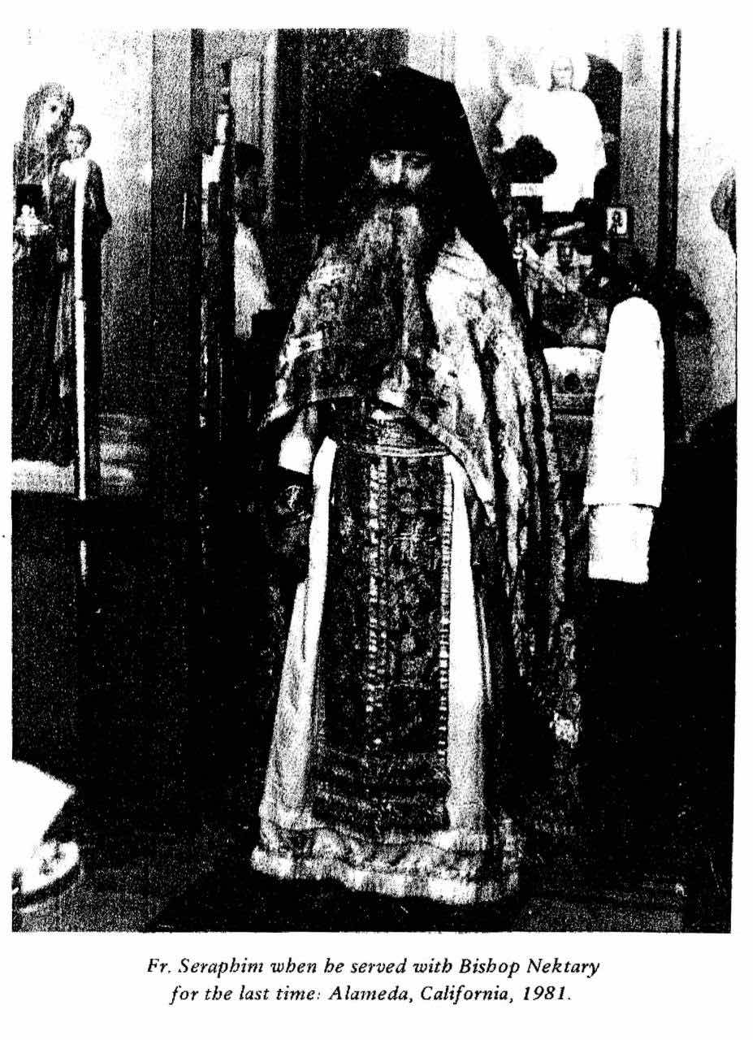

THE LAST TRUE REBELLION

The Radical, Catacomb teaching of Monk Seraphim Rose by Monk Damascene Christensen

It's all over for what was once known as Christian civilization. We're living in a post-Christian age. As the mad prophet Friedrich Nietzsche said, "The 20th century will be the triumph of NIHILISM." And this triumph, said Monk Seraphim Rose, will end in a reign of ANARCHY. "Nihilism is the means, Anarchism is the end."

"Nihilism" comes from the word nihil, meaning "nothing." Nietzsche defined Nihilism thus: "There is no truth. There is no absolute state of affairs--no 'thing-in-itself.' This alone is Nihilism, and of the most extreme kind." Fr. Seraphim wrote that "Nihilism has become, in our time, so widespread and pervasive, has entered so thoroughly and so deeply into the minds and hearts of all men living today, that there is no longer any 'front' on which it may be fought.

This is the mind-set of modern society, and it is the wave of the future. But if abandonment of Truth has become the mainstream, who then are the rebels? Not the Nihilists who openly declare that life has no meaning and live as though it did not. They are only victims who have been devastated by the spirit of the times. The "Christians,"then? Not if they've sold out to the world, and, while immersed in their slick, squeaky-clean worldliness, act as if they're trying to stand for something otherworldly.

No, the true rebels are those who, by their deeds and lives, spit on both the falsness of the world and on the mainstream of Nihilism that refuses to see above this world. Such a rebel was Monk Seraphim Rose.

Fr. Seraphim was born into a typical white, middle-class Protestant family in San Diego in 1934. While growing up, he was the proverbial dutiful child and academic achiever. After high school, however, he began to passionately seek the answer to the question "Why?"--and, not finding it in the society in which he had been raised, he began to rebel. He refused to accept the accepted answers. This was at the very beginning of the modern counterculture, the early 1950's. Fr. Seraphim became a student of one of the counterculture's first pioneers, Alan Watts (whom he later realized was totally pseudo) and became a Buddhist Bohemian in S.F. He learned ancient Chinese in order to study the Tao Teh Ching and other ancient Eastern texts in their original language, hoping thereby to tap into their heart of their wisdom. By this time he had wholly rejected the Protestant Christianity of his formative years, which he regarded as worldly, weak, and fake; he mocked its concept of God and said that it "put God in a box." He read Nietzsche until that prophet's words began to resonate in his soul with an electric, infernal power.

All this time, he had been seeking the Truth with his mind, but the Truth had eluded him. He fell into a state of despair which he described in later years as a living hell. He felt he did not fit in the modern world, even in his own family, who did not understand him. It was as if he had somehow been born out of place, out of time. He loved to roam under the stars, but he felt that there was nothing out there to take him in--no God, nothing. The Buddhist "nothingness" left him empty, just as it did the founder of the Beat movement Jack Kerouac; and, like Kerouac, Fr. Seraphim turned to drink. He would drink wine voraciously, and then would pound on the floor, screaming at God to leave him alone. Once while drunk, he raised a fist to heaven from a mountaintop, cursed God and dared Him to damn him to hell. In his despair, it seemed worth being damned forever by God's wrath, if only he could empirically know that God exists--rather than remain in a stagnant state of indifference. If God did damn him to hell, at least then he would, for that blissful instant, feel God's touch and know for sure that He was reachable.

"Atheism," Fr. Seraphim wrote in later years, "true 'existential' atheism burning with hatred of a seemingly unjust or unmerciful God, is a spiritual state; it is a real attempt to grapple with the true God Whose ways are so inexplicable even to the most believing of men, and it has more than once been known to end in a blinding vision of Him Whom the real atheist truly seeks. It is Christ Who works in these souls. The Antichrist is not to be found primarily in the great deniers, but in the small affirmers, whose Christ is only on the lips. Nietzsche, in calling himself Antichrist, proved thereby his intense hunger for Christ...."

In searching through various ancient religious traditions, Fr. Seraphim once went to visit a Russian Orthodox church. Later he wrote about this experience:

"For years in my studies I was satisfied with being 'above all traditions' but somehow faithful to them.... When I visited an Orthodox church, it was only in order to view another 'tradition.' However, when I entered an Orthodox church for the first time (a Russian church in San Francisco) something happened to me that I had not experienced in any Buddhist or other Eastern temple; something in my heart said that this was 'home,' that all my search was over. I didn't really know what this meant, because the service was quite strange to me, and in a foreign language. I began to attend Orthodox services more frequently, gradually learning its language and customs.... With my exposure to Orthodoxy and to Orthodox people, a new idea began to enter my awareness: that Truth was not just an abstract idea, sought and known by the mind, but was something personal--even a Person--sought and loved by the heart. And that is how I met Christ."

On becoming Orthodox, Fr. Seraphim continued to despise the modern world and hoped for nothing from it; he wanted only to escape it. He felt no less, if not more, estranged from the Christianity he had been raised in, for while that Christianity was at home in the world, his was radically otherworldly. He had finally found the designation of man's existence, and it was this: man is meant for another world.

Fr. Seraphim's was an ascetic faith. He wanted a Christianity that emphasized not earthly consolation and benefits, but rather heavenly redemption through intense suffering on earth. No other kind rang true to him who had suffered so much. Only a God Who allowed His children to be perfected for heaven through suffering, and Who Himself set the example by coming to a life of suffering--only such a God was capable of drawing the afflicted world to Himself and was worthy to be worshipped by the highest spiritual faculties of man.

In his journal, Fr. Seraphim wrote: "Let us not, who would be Christians, expect anything else from it than to be crucified. For to be Christian is to be crucified, in this time and in any time since Christ came for the first time. His life is the example--and warning-- to us all. We must be crucified personally, mystically; for through crucifixion is the only path to resurrection. If we would rise with Christ, we must first be humbled with Him--even to the ultimate humiliation, being devoured and spit forth by the uncomprehending world.

"And we must be crucified outwardly, in the eyes of the world; for Christ's Kingdom is not of this world, and the world cannot bear it, even a single representative of it, even for a single moment. The world can only accept Antichrist, now or at any time.

"No wonder, then, that it is hard to be a Christian--it is not hard, it is impossible. No one can knowingly accept a way of life which, the more truly it is lived, leads the more surely to one's own destruction. And that is why we constantly rebel, try to make life easier, try to be half-Christian, try to make the best of both worlds. We must ultimately choose--our felicity lies in one world or the other, not in both.

"God give us the strength to pursue the path of crucifixion; there is no other way to be a Christian."

Before he had found the Truth Fr. Seraphim had suffered for the lack of it. Now having found it he suffered for the sake of it. He devoted the rest of his life to living that Truth, and killing himself to give it to others. Together with a young Russian man named Gleb Podmoshensky, he formed a Brotherhood which practiced the "Do It Yourself" philosophy. They opened a bookstore in S.F. and began printing a small magazine by hand on a letterpress, refusing to become a dependent arm of the worldly church establishment. Later, partly to avoid this very establishment, they moved their printing operation to the wilderness of northern California, where they began to live like the "desert-dwellers" (wilderness ascetics) of ancient times. There was no running water on their forested mountain, no telephone, no electric lines. They built their buildings themselves out of lumber taken from old pioneer dwellings, and hauled water on their backs up the mountain. They lived with deer, bear, foxes, rabbits, squirrels, bats, mountain lions, scorpions, and rattlesnakes.

In 1970 they became monks, thus dying forever to the world. At this time the church establishment tried to shut down their wilderness hermitage and make them standard pastors for parishes in the world. The two monks fought long and hard against this, and after much suffering achieved victory.

In the wilderness, Fr. Seraphim's spirit began to soar. "The city," he once said, "is for those who are empty, and it pushes away those who are filled. The desert keeps those who are filled and allows them to thrive."

Working by candlelight in his tiny cabin, Fr. Seraphim produced a great number of original writings and translations of ancient ascetic texts. In America his writings have so far reached only select circles, but in countries formerly behind the Iron Curtain they have had an incalculable impact on human lives. During the Communist era, they were secretly translated into Russian and distributed in the underground press ("samizdat") in the form of typewritten manuscripts. By the time of the fall of Communist Power in 1991, Fr. Seraphim was known all over Russia. Today his books are on sale everywhere in Russia, including booktables in the Metro (subway) and on the street. The reason that he has made a much greater mark on Russia than on his homeland is because in Russia people know how to suffer. Fr. Seraphim's message of underground Christianity, of suffering and persecution in this world for the sake of Truth, touches a responsive chord in people who have already been crucified. In America people would rather hear the "nice" messages of preachers like Rev. Robert Schuller (who, by the way, broadcasts his show to Russia, where people can hardly believe how stupid it is).

I met Fr. Seraphim a year and a half before his death in 1982. Like him, I had been seeking Reality through Eastern religions, etc., by seeking to escape pseudo-reality through a Zen- like breakdown of logical thought processes. Finally reduced to despair, I listened to Syd Barrett's two schizophrenic-withdrawal, childhood-regression solo albums over and over, until I had memorized all his word-salads. (In Russia, this is known as "going crazy on a full stomach.")

Then one day Fr. Seraphim came to the campus where I was going to school. He drove up in an old beat-up pickup truck, and emerged with his worn-out black robe, his long hair, and his exceedingly long gray beard which had become matted (I found out later that he had not taken a bath or shower since becoming a monk ll years before--which is common monastic practice in Israel, Greece, and Egypt--but for some reason he didn't smell). It was the image of absolute poverty.

The next thing I remember is walking with Fr. Seraphim through the college. Dinner had just ended, and the students were milling and hanging around outside the cafeteria. Everyone was staring at Fr. Seraphim, but he walked through them as naturally as if he had been at home. In the middle of this progressive American college, he seemed like someone who had just stepped out of the 4th-century Egyptian desert.

Fr. Seraphim went to a lecture room and delivered a talk called "Signs of the Coming of the End of the World." He happened to be sick at this time, and sniffled throughout the lecture. Obviously exhausted, he yet remained clear-headed, cheerful, and ready to answer questions at length. I could see that he was at least as learned and far more wise than any of my professors, and yet he was clearly a man off the wilderness, more at home in a forest than in a classroom.

What struck me most about Fr. Seraphim was that here was a man who was sacrificing himself totally for God, for the Truth. He was not a university professor receiving a comfortable salary for being a disseminator of knowledge, nor was he a religious leader who hankered after power, influence, or even a bowl of fruit to be placed at his feet, as did the "spiritual masters" who then had followings in the area. He was not "into religion" for what he could get out of it; he was not looking for a crutch, to "enjoy spiritual life." He was just a simple monk who sought the Truth above all else. And I knew beyond a shadow of a doubt that he would die for that Truth, for I could sense that he was dying for it already.

As we have said, Fr. Seraphim's message falls on many a deaf ear here in America. Even people in his same church will only listen to so much of it. When they think they might have to go against public opinion and risk losing recognition and acceptance by the world (including the "church world"), they stop short. And yet the Crucified God to Whom they give lipservice once said to His disciples: "If the world hate you, ye know that it hated me before it hated you. If ye were of the world, the world would love his own: but because ye are not of the world, but I have chosen you out of the world, therefore the world hateth you." "In the world ye shall have tribulation: but be of good cheer; I have overcome the world."

Those who have suffered immense pain in this world can believe far more deeply than those who have not, that there must be another world. Those who, like Fr. Seraphim, have felt themselves out of place in modern society, who have been "devoured and spit forth by the uncomprehending world," can understand better Christ's radical call of rejection of the world and rebellion against it. Thus it is not the "accepted" ones who can hear Fr. Seraphim's message "not of this world" and carry it out to the end. Just as in the time of Christ, it is the outcasts who get the point. Even an atheist may be closer to God than a "right-believing" one, if the former is suffering in his unbelief and the latter is smug and complacent in his belief. As Fr. Seraphim said, God is working in the souls of the "great deniers" more than in those of the "small affirmers."

It is not accidental, then, that while many people in Fr. Seraphim's church only go halfway with his teaching, there is a growing number of people from the punk movement who are going all the way with it. Several punx have joined the Brotherhood he founded and are dying to the world as monastics, having found ancient Orthodox monasticism to be the ultimate punkdom.

As early as 1960, Fr. Seraphim had come to many of the conclusions that the punx of today have come to. He said that humanity, when divorced from God, naturally becomes SUBHUMANITY, and that Humanism becomes Subhumanism. Those artists and musicians who depict modern, godless, autonomous man as empty, despairing, enraged and dehumanized, hit closer to the truth than the naive, happy humanist who tries to look at the modern situation with optimism.

A few years later, in 1962, Fr. Seraphim wrote an essay in which he traced the course that Nihilism takes, directed by the Evil One. His words proved prophetic in subsequent decades.

At the first stage of Nihilism, he said, is "Liberalism," by which he meant the attempt to work out a compromise between the Old Order ("Christian civilization") and the New Order of humanity without God. At the second stage is Realism, in which belief in the other world and transcendent Truth is abandoned and the whole concentration is on the material world, physical well-being, technical progress, etc. Realism, however, denies man's unplanned, irrational needs, and therefore must evoke a reaction against it, which is the third stage: Vitalism. In the Vitalist stage, the criterion of Truth is substituted by a new standard: the "life-giving," the "vital." This may take the form of pseudo-spiritual experiences, the invoking of "powers" and "presences," or else of the "cult of nature" with its primary elements of the earth, the body, and sex. Vitalism, Fr. Seraphim said, is "an unmistakable symptom of world-weariness. It is the product, not of the 'freshness" and 'life'and 'immediacy' its followers so desperately seek (precisely because they lack them), but of the corruption and unbelief that are but the last phase of the dying civilization they hate."

Thus, Fr. Seraphim believed, beyond Vitalism there can be only one more, definitive stage through which Nihilism may pass: the Nihilism of Destruction. "Here at last," he wrote, "we find an almost 'pure' Nihilism, a rage against creation and against civilization that will not be appeased until it has reduced them to absolute destruction."

Since Fr. Seraphim wrote about this in 1962, the youth movements have tended to correspond with the stages he outlined. The hippie movement of the 60's and early 70's was an example of Vitalism reacting against the dead Liberalism and dry Realism of the 50's (when sclence was expected to take care of everything, conformity was the rule, and spiritual seeking looked down upon). By the 80's and 90's, the ideals of the hippies had proved naive and simplistic, and their Vitalism gave way to manifestations of the Nihilism of Destruction in a now far more fragmented youth culture. This is where we are at today. And beyond it, Fr. Seraphim said, is Anarchy.

"The Nihilism of our times exists in all," Fr. Seraphim wrote, "and those who do not, with the aid of God, choose to combat it in the name of the fullness of Being of the living God, are swallowed up in it already. We have been brought to the edge of the abyss of nothingness and, whether we recognize its nature or not, we will, through affinity for the ever-present nothingness within us, be engulfed in it beyond all hope of redemption--unless we cling in full and certain faith (which, doubting, does not doubt) in Christ, without Whom we are truly nothing....

"Facile interpretations of the 'crisis,' of the 'choice' before us, abound; to take either side of these illusionary interpretations is damnation. The true crisis is now, as it has ever been, within us; it is our acceptance or negation of Christ. Christ is our crisis; He; demands from us all or nothing, and this 'problem' He presents us is the only one that need be answered.... Do we choose God, Who alone IS, or ourselves, nothingness, the abyss, Hell? Our age is founded upon nothingness; but this nothingness, inexplicably to us, presents, for those who can still perceive, the crisis of all men in all ages most clearly and unmistakably. Our age tells, if we can listen, to choose the living God."

